Please Check:

Graduate Midwife Registered Nurse

Name of Applicant: ________________________________________ School: ______________________________________

Name and Address of Patient | Case No. | Internal Examination (Cervical Dilation, Effacement, BOW, Presentation & Station) | Date & Time Performed | Full Name, Address of Facility & Contact Number | Supervised by:
 |  |  |  |  | Printed Name & Contact No. | Position/ Designation | Signature | License No./ Expiration Date
1.
2.
3.
4.
5.
6.
7.
8.
9.
10.

(Continued at the Back)

Name and Address of Patient | Case No. | Internal Examination (Cervical Dilation, Effacement, BOW, Presentation & Station) | Date & Time Performed | Full Name, Address of Facility & Contact Number | Supervised by:
 |  |  |  |  | Printed Name & Contact No. | Position/ Designation | Signature | License No./ Expiration  Date
11.
12.
13.
14.
15.
16.
17.
18.
19.
20.
Note: 1) The Clinical Instructor should ensure the competence of the students in the performance of internal examinations before signing this form.
2) Registered Midwives/Clinical Instructors who supervise Students/Graduate Midwives/Registered Nurses and affix their signature in this Form must present a
Certificate of Training on the Expanded Functions of Midwife (R.A. 7392) pursuant to Board Resolution No. 07, Series of 2017, dated September 8, 2017.

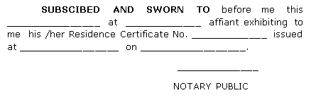

Affix
Documentary Stamp
(to be posted on the last page)

CERTIFIED CORRECT:

Signature: Date:
Printed Name:
Designation: _______________________________
License Number: Expiry Date:

